SPAY/NEUTER FORM ONE APPLICATION PER PET ENCLOSE CO-PAY WITH EACH APPLICATION PER ANIMAL
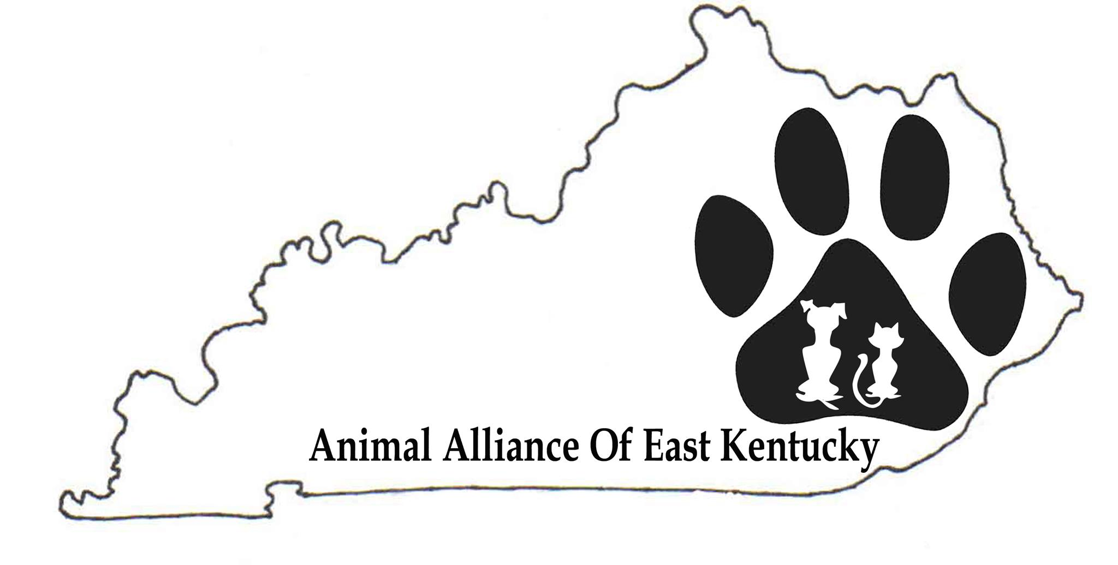 | ANIMAL ALLIANCE OF EAST KENTUCKY, INC.  SERVICE AREA: FLOYD, JOHNSON, MAGOFFIN, MARTIN  - Promote the importance of spaying/neutering and campaign for low cost spay/neuter opportunities.  - Raise awareness of humane treatment of animals through public education.  - Increase volunteer participation and fundraising activities.  - Participate in activities that result in the placement of companion animals in loving, responsible homes.

Pet Owner Information – 1 APPLICATION PER ANIMAL

Name

Mailing Address

City, State Zip

Physical Address

Driver’s License #

Phone 1 | Phone 2

Fax | Email

Assistance program
I (we) receive assistance at this time: ☐ yes (name program below). Food stamps, Medicaid, Social Security, SSI, SSD, Pension, Unemployment

Program

CO-PAY REQUIRED according to your yearly income to help offset the cost of spay/neuter.
At this time, AAEKy will limit procedures to two per household within a 3 year time frame.
PLEASE FILL OUT ONE APPLICATION PER ANIMAL WITH REQUIRED CO-PAY MAILED WITH APPLICATION.
CHECK OR MONEY ORDER ONLY- DO NOT SEND CASH

$15.00, if income is $0 - $25,000 ☐ mail with application
$25.00, if income is $26,000 - $50,000 ☐ mail with application
$40.00, if income is $51,000 + ☐ mail with application

Your co-pay allows AAEKy to assist more pets in the community. Please enclose co-pay with mailed application.

1 APPLICATION PER ANIMAL. MAIL C0-PAYMENT WITH APPLICATION.
PET NAME REQUIRED | PET NAME:___________________________________________________
Circle Cat or Dog | CAT DOG
Circle Sex | MALE FEMALE If female, how many litters has she had?# -------
FILL IN ALL INFO RELATED TO: | Age __________/ Weight _______________/ Breed ________________

Long Hair/Short Hair/Color/ Special Markings

Any Health Concerns

IS THIS ANIMAL A COMPANION ANIMAL/FAMILY PET? ___________________________

HOW LONG HAVE YOU HAD YOUR FAMILY PET? ____________________________

DO YOU PLAN TO KEEP THIS FAMILY PET IN YOUR HOUSEHOLD AFTER SURGERY?

If not, please explain: _____________________________________________________

Acknowledgement Information
Photos tell the story and give life to our program. Please authorize AAEK to use your PET’S photo in newspaper and all recognized social media.
☐ YES, I authorize use of PET photo (vet may take photograph)
☐ YES, I would love to provide a photo of me and my PET.

LIABILITY CLAUSE
I, the undersigned owner, or owner's agent, of the pet (animal) identified above, certify that I am over eighteen years of age, and hereby authorize & consent for the hospitalization, examination, medication, treatment, anesthesia, and spay/neuter surgery of the dog or cat by staff veterinarian(s) at the clinic AAEKy schedules on your pet’s behalf. Please check preferred Veterinarian Clinic, if none selected, it will be assigned:

☐ Highlands Veterinarian Clinic, 1979 KY Route 40 E, Paintsville, KY or
☐ Country Hills Veterinary Hospital, 30 Travis Branch East Point, KY
You are to use all reasonable precaution against injury, escape, or death of my pet. I understand that some risks always exist but is not limited to all medications, vaccines, anesthesia and/or surgery including unknown physical abnormalities, medication allergies, surgical complications, internal bleeding, shock, incision dehiscence, and post-surgical infections. I agree to hold said veterinary clinic, its owners, and all employees harmless and free of any liability whatsoever in connection with these procedures risks in the absence of negligence. I acknowledge that no guarantee or assurance has been made to me as to the results that may be obtained. In the event complications arise and I cannot be- immediately contacted at the below listed phone number, you are directed to make the decision you deem best for my pet.

I understand that the basic low-cost spay/neuter procedure is primarily intended for those with very limited financial sources and that the basic fee includes general anesthesia (injectable only), surgical prepping, surgical procedure itself, pain control during the procedure itself only, and the suture removal required in 10 days. I also agree to hold AAEKy’s board of directors harmless and free of any liability whatsoever in connection with the said procedure for pet’s surgery.

By signing, dating and submitting the application form to AAEKy, you are agreeing to accept the liability clause. Application must be sent by mail with required co-pay enclosed. If application is not approved, check will be returned by mail. Please print, completely fill in and mail to AAEKy at address above.

Signature(s) |  | Date
 |  | MAIL APPLICATION TO:

ANIMAL ALLIANCE OF EAST KENTUCKY, INC.

PO Box 324

Paintsville KY 41240
Revised 04/13/18 09-07-18

PLEASE KEEP THIS INFO FOR YOUR REFERENCE
INFORMATION WHICH IS PERTINENT TO SURGICAL PROCESS-
CANCELLATIONS
If you are not able to keep your appointment, please contact your veterinarian. ASAP. A 24 hour notice is requested.
NIGHT BEFORE SURGERY
If the animal normally stays outdoors overnight, please consider bringing it indoors the evening before surgery as animals over four months old MUST have food withdrawn at midnight the night before surgery. This ensures that the animal's stomach is empty by the time he's put under general anesthesia. This lessens the chances that the animal will vomit and aspirate the vomit into his lungs. If your adult pet has eaten on the morning of surgery, we will refuse surgery.
CHECK-IN TIME
1) It is very important that you arrive on time for your scheduled appointment
2) Plan to be at the veterinarian’s office 30 minutes before scheduled appointment.
3) When you arrive please leave your pet in the car and come inside first to complete the required paperwork, bring your pet in when completed.
Please note that in the rare event of unforeseen circumstances or emergencies at the clinic there may be a longer wait at check-in or your pet’s surgery may need to be rescheduled.

PRE-SURGERY EXAM
1) The veterinarian will perform a pre-operative physical examination to make sure that your pet is a good candidate for surgery.
2) If your pet is too unruly to handle, a physical exam will be performed under anesthesia.
3) Feral cats may receive their physical exams under anesthesia.
4) If your pet shows signs of illness or if there are any concerns (such as age, a heart murmur, severe upper respiratory infection, obesity, food in stomach) we may refuse surgery if we feel surgery is a health risk.

CATS - WHAT TO BRING TO YOUR APPOINTMENT
1) Cats must be in a clean pet carrier commercially manufactured for the purpose of transporting felines with a secured door. Vets DO NOT ACCEPT animals in cardboard boxes, plastic totes, laundry baskets, or other non-standard or homemade devices.
2) Your pet needs to be able to lie down comfortably in the carrier after surgery. Your pet may be agitated or aggressive when they go home due to the after-effects of anesthesia. Cats that routinely get along well may not be tolerant of each other in the immediate post-operative period. Keeping your cat comfortable by itself might be a consideration.
3) If your pet has current vaccination records please bring them. If your pet has a current rabies vaccine, we need to see proof (actual rabies certificate).
DOGS - WHAT TO BRING TO YOUR APPOINTMENT
1) Dogs must be under control on a leash or in a clean pet carrier.
2) If your dog is not good-natured around other dogs, cats or people a muzzle is required.
3) Please take your dog for walk before you arrive as he/she will be in a kennel all day.
4) If your pet has current vaccination records please bring them. If your pet has a current rabies vaccine, we need to see proof (actual rabies certificate).
FUTURE CARE FOR YOUR PET
AAEKy appreciates your taking the time to get your animal spayed/neutered and congratulates you for joining the mission of reducing pet overpopulation. For your animal’s continued health and welfare, AAEKy encourages to continue health and wellness visits with the veterinarian who spayed/neutered your pet. Future care appointments will need to be made by you and will be at your own expense.

